Soroptimist International of
St. Helena & St. Helena Sunrise
Present
Identifying & Reporting
Human Trafficking

Resources
The National Human
Trafficking Hotline
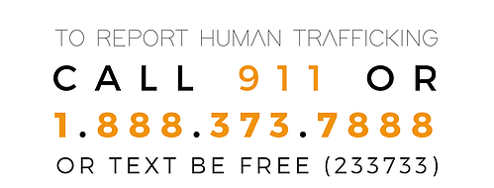

Wednesday March 27, 2019
9:00 a.m. – 1:00 p.m.
Harvest Inn
1 Main Street, St. Helena

Program facilitated by

The Napa Special Investigations
Bureau
Hotline 707-224-3784
707-253-4458

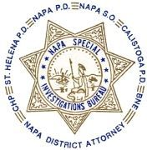

ANTI-SEX TRAFFICKING

SURVIVOR-LED

ORGINIZATION
707.382.5360
info@itsgameover.org
itsgameover101

Free to the Public
Space is limited - please RSVP to
GinaLewis46@gmail.com

Human Trafficking is not a gender specific crime; if you or anyone you know is in immediate danger please call 911

- History of running away or currently is a runaway
- Unstable home life/or involvement in the child welfare or foster care systems
- Has items or an appearance that doesn’t fit the current situation (money, hair, nails, electronics, etc.)
- Older boyfriend
- Morals and values have slowly expanded
- New tattoo or “brand”
- Starts to become secluded
- Suddenly has expensive items: name-brand purses, diamonds, etc.

